**Pension Benefits Application (21P-527EZ)**

Table of Contents

Pension Benefits Application Overview 2

User Access 2

Who can access this application? 2

Navigation 3

How Do I Apply 4

Pension Benefits Application 5

Step 1: Applicant Information 5

Step 1: Applicant information / Mailing address 7

Step 1: Applicant information / Email and phone number 9

Step 2: Military History 10

Step 3: Health and employment information / Age 13

Step 3: Health and employment information / Social security disability 14

Step 3: Health and employment information / Special monthly pension 16

Step 3: Health and employment information / Treatment from a VA medical center 18

Step 3: Health and employment history / Treatment from federal medical facilities 19

Step 3: Health and employment history / Current employment 20

Step 4: Household information / Marital status 23

Step 4: Household information / If married or separated 23

Step 4: Household information / Previous marriage 24

Step 4: Household information / Current marriage 25

Step 4: Household information / Current marriage, if they do not live with spouse 26

Step 4: Household information / Current marriage, if they are separated 27

Step 4: Household information / If married or separated 28

Step 4: Household information / If married or separated / If current spouse has been married before 29

Step 4: Household information / Dependent children 30

Step 5: Financial information / Income and assets 31

Step 5: Financial information / Gross monthly income 36

Step 5: Financial information / Care expenses 38

Step 5: Financial information / Medical expenses 40

Step 6: Additional information / Direct deposit 42

Step 6: Additional information / Supporting documents 43

Step 6: Additional information / Submit your supporting documents 44

Step 6: Additional information / Faster claim processing (optional) 46

Step 7: Review application 48

# Pension Benefits Application Overview

This product guide covers the online application for veteran pension benefits (21P-527EZ).

## User Access

### Who can access this application?

Veterans do not need to be signed into complete this application. However, if they aren’t signed in, the application will not be prefilled with their information and the veteran will not be able to save their application in progress. You can reference the below screenshot for more information on this: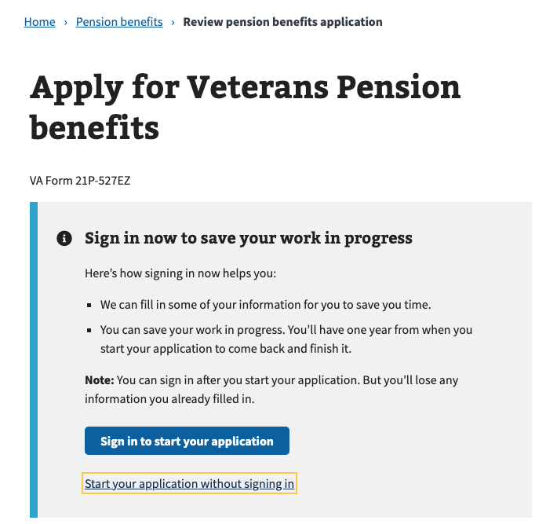

## Navigation

**Direct url:**​ https:[www.va.gov/pension/application/527EZ/introduction](http://www.va.gov/pension/application/527EZ/introduction)

**Or** the link can be found in the dropdown menu:

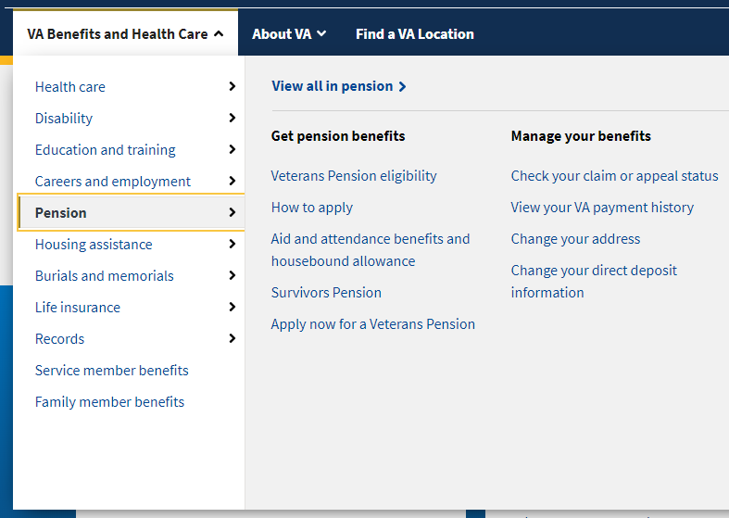

**Or** on the Pension Benefit Hub Page: <https://www.va.gov/pension/>

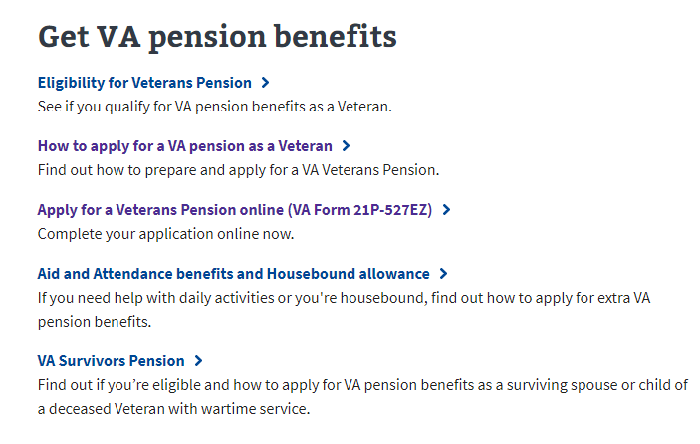

# How Do I Apply

<https://www.va.gov/pension/how-to-apply/>

This web page provides instructions on how to apply for veterans pension benefits and what information is needed to complete the application. This page also directs the user to the application once they are ready to apply:

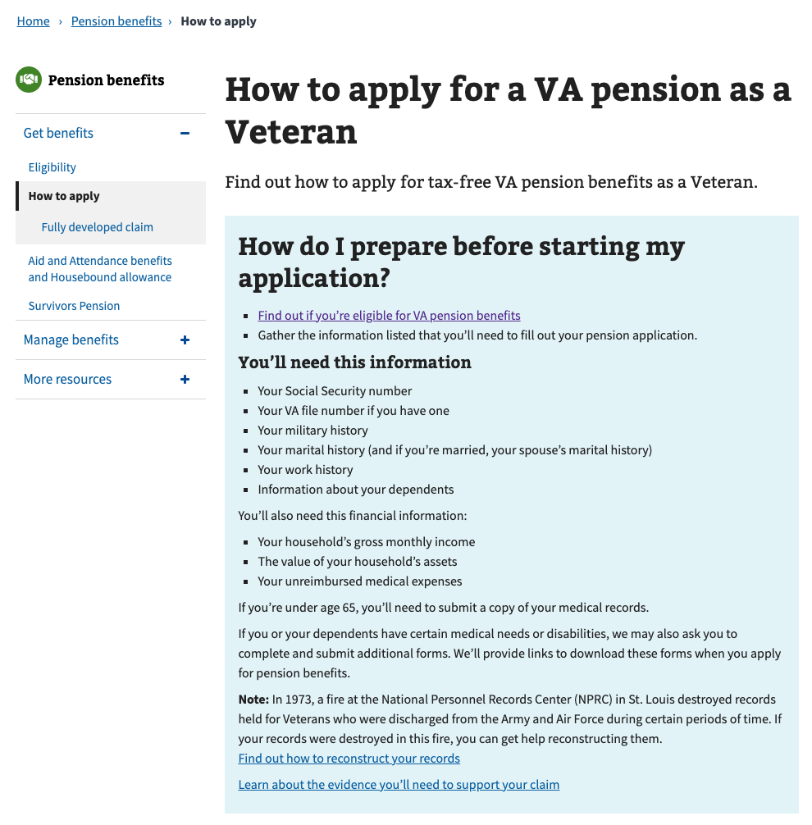

# Pension Benefits Application

### Step 1: Applicant Information

First, the user will be asked to fill in general personal information. If they are signed in, the application will be pre-filled but the veteran can also change this information. If they are not signed in, they will need to add the information.

The application will tell the veteran what must be filled in. If they do not enter all t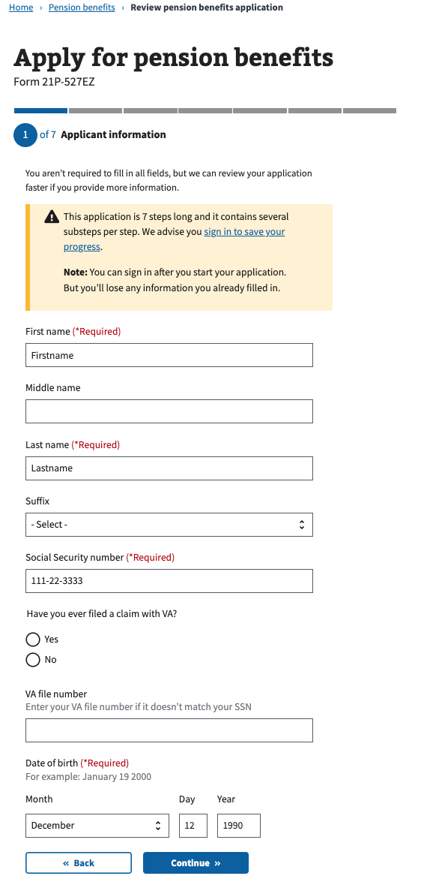he required information, they will not be allowed to move on to the next page.

### Step 1: Applicant information / Mailing address

Next, the veteran will be asked to enter all of their mailing address. If they check the box that they receive mail outside of the US on a military base, the Unites States is automatically chosen non their country.

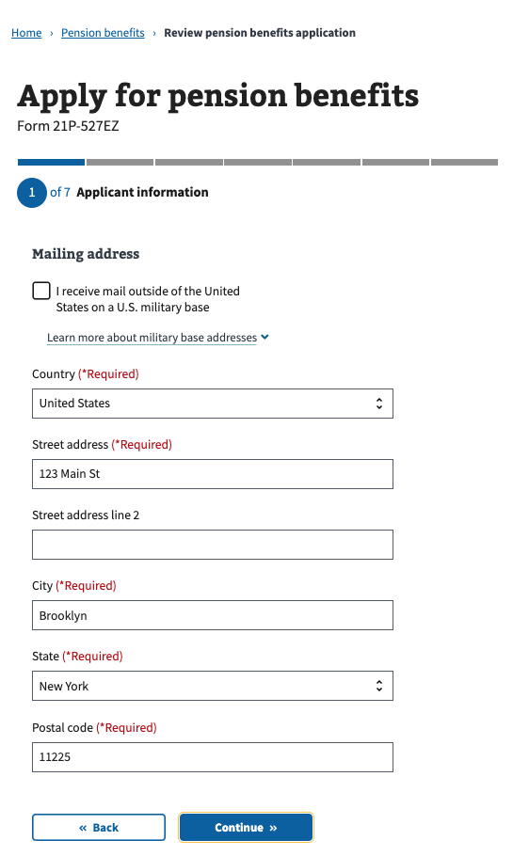

### Step 1: Applicant information / Email and phone number

Next, the veteran will be asked to enter their email address and phone number(s), including an international phone number, if they have one.

### Image

### Step 2: Military History

Next, the veteran will be asked to enter their branch(es) of service, the dates they entered and ended their active duty, and a military service humber, if they have one:

### Image

The veteran will also be asked if they serviced another another name. If so, they are required to enter that name. They will also ask for their place of separation from their service: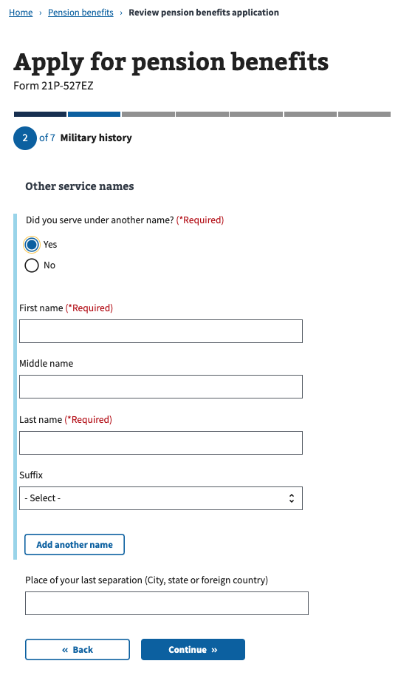

The veteran will also be asked if they have ever been a prisoner of war. If so, they must enter their start and end dates of confinement: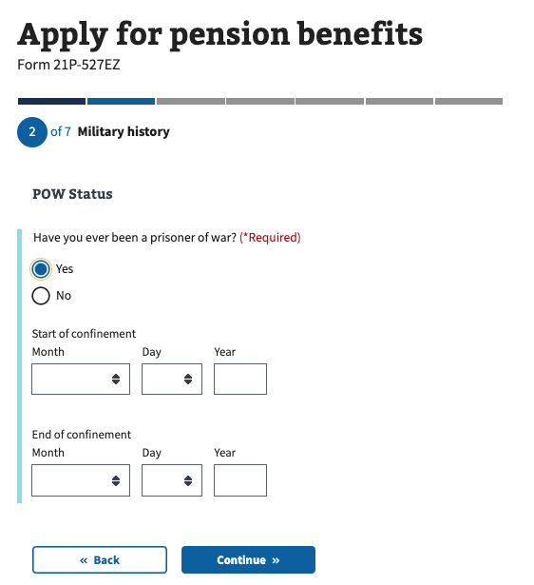

### Step 3: Health and employment information / Age

Next, the veteran will be asked whether they are 65 years or older: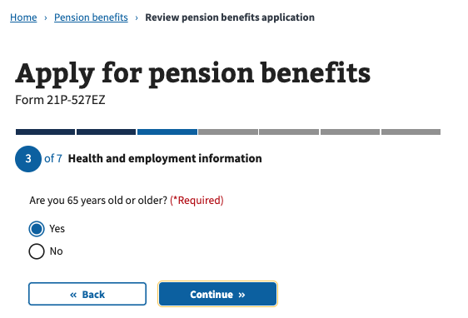

### Step 3: Health and employment information / Social security disability

Next, the veteran will be asked whether they currently receive SS disability payments.

If they answer ”no” to “Are you 65 years old or older?”, they will see an alert that states they need to provide medical evidence with this application.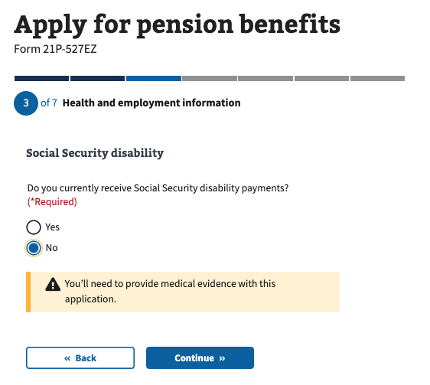

If the veteran answers “yes” to “Are you 65 years old or older?”, they will be asked if they live in a nursing home and if Medicaid covers all or part of their nursing home costs: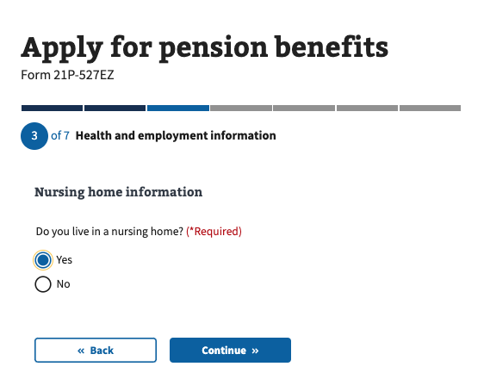

### Image

If the veteran answers “no” to “Do you currently receive SS disability payments?”, they will be asked an additional questions asking if they have a medical condition that prevents them from working.

If they answer ”yes”, they will see an alert that states they need to provide medical evidence with this application: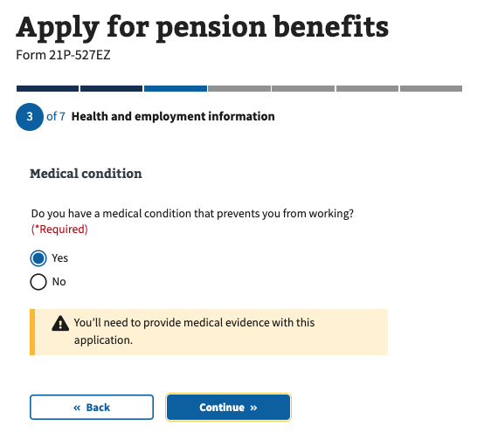

### Step 3: Health and employment information / Special monthly pension

Next, the veteran will be asked if they are claiming special monthly pension.

If they answer ”yes”, they will see an alert that states they will need to fill out form 21-2680.

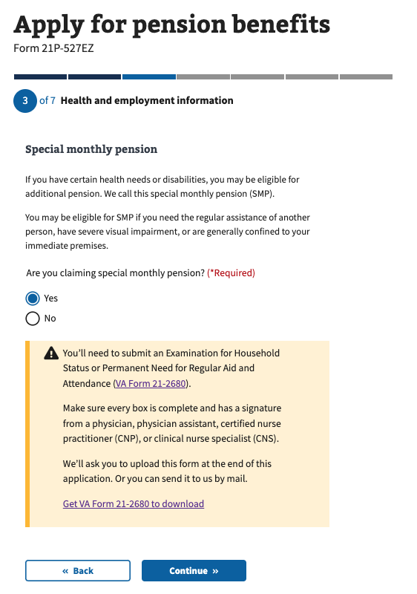

### Step 3: Health and employment information / Treatment from a VA medical center

Next, the veteran will be asked if the have received treatment from a VA medical center.

If they answer ”yes”, they will be asked to enter what they are.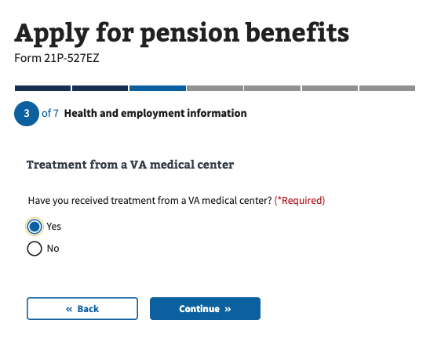

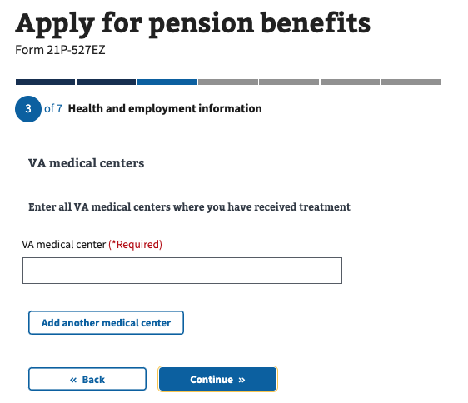

### Step 3: Health and employment history / Treatment from federal medical facilities

Next, the veteran will be asked if the have received treatment from any federal medical facilities, such as military bases or prisons.

If they answer ”yes”, they will be asked to enter what they are.

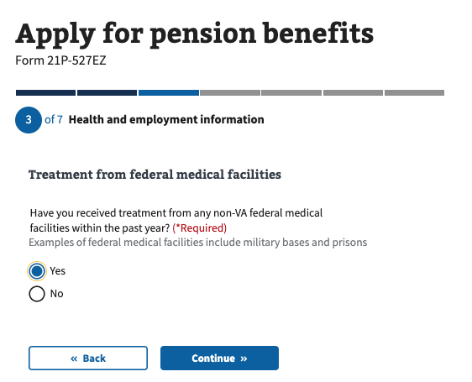

### Image

### Step 3: Health and employment history / Current employment

Next, the veteran will be asked if the are currently employed.

If they answer “yes” to “Are you currently employed?”, they will be asked to enter what kind o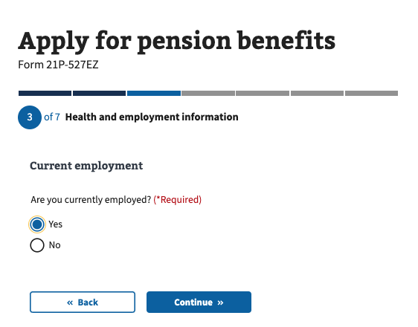f work they do, how many hours per week they work on average, and their job title:

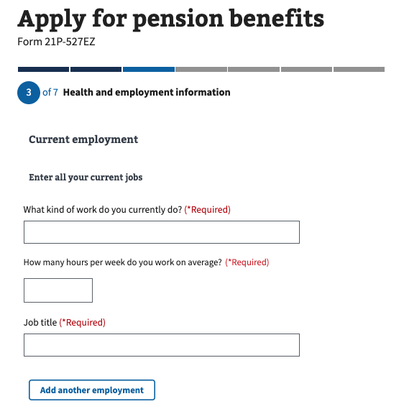

Similarly, if they answer “no” to “Are you currently employed?”, they will be asked to enter a date when they last worked, what kind of work they did, how many hours per week they worked on average, and what their job title was:

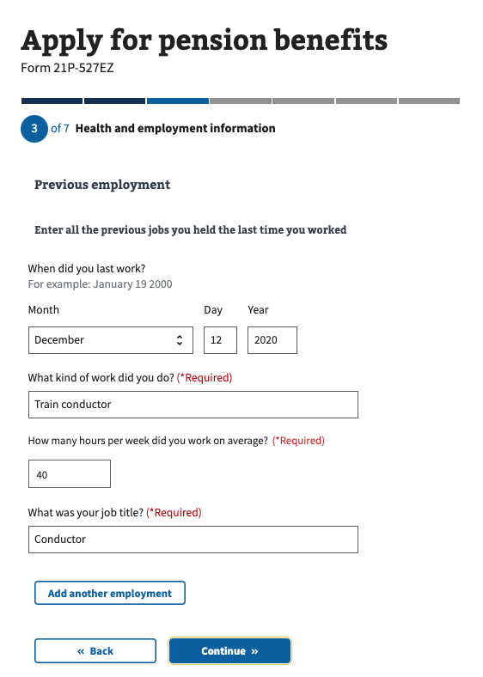

### Step 4: Household information / Marital status

The first question of this step will ask the veteran what their current marital status is:

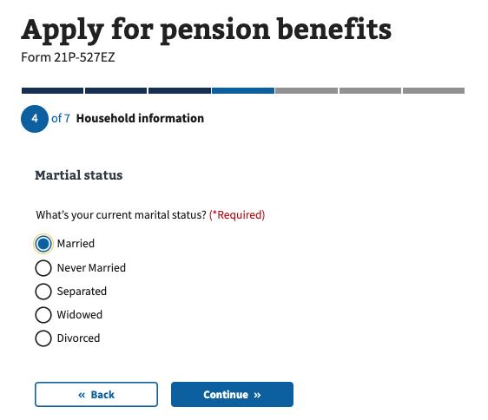

If the veteran answers “never married”, “widowed” or “divorced”, they will skip to the section that asks about dependent children.

### Step 4: Household information / If married or separated

Next, if the veteran answered “married” or “separated”, they will be asked how many times they have been married:

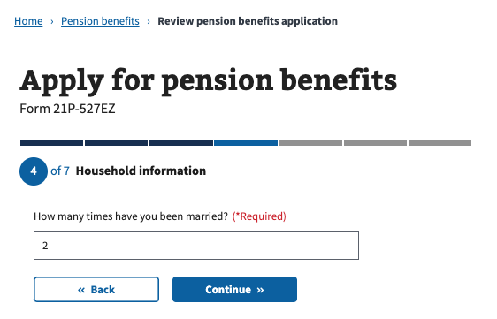

### Step 4: Household information / Previous marriage

Next, if the veteran answered “married” or “separated”, and they have been married more than once, they will be asked to enter information about their former marriage including their name, dates for start and end of marriage, places of marriage start and end, and how the marriage ended:

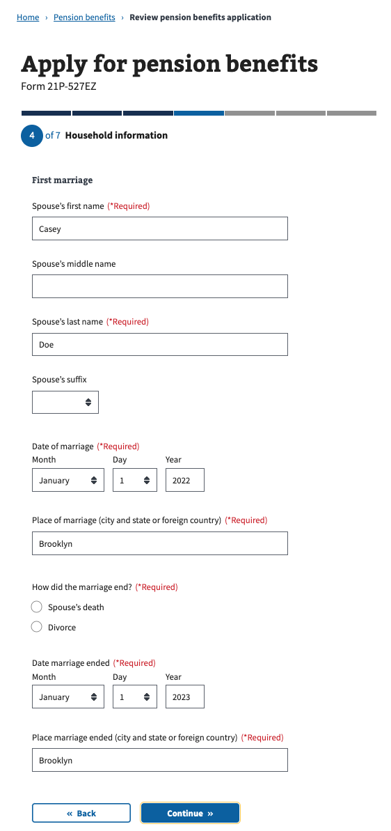

### Step 4: Household information / Current marriage

Next, if the veteran answered “married” or “separated”, they will be asked to enter information about their current marriage including their name, date of marriage, place of marriage and type of marriage.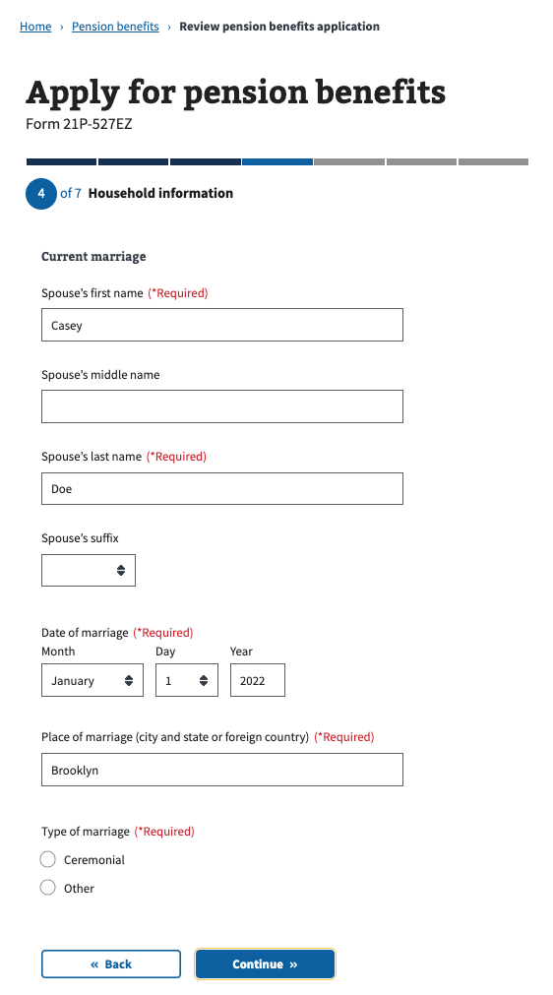

On the next page, they will also be asked about their spouse’s date of birth, social security number, if they are a veteran (if so, add a VA file number), and whether they live with their spouse or not.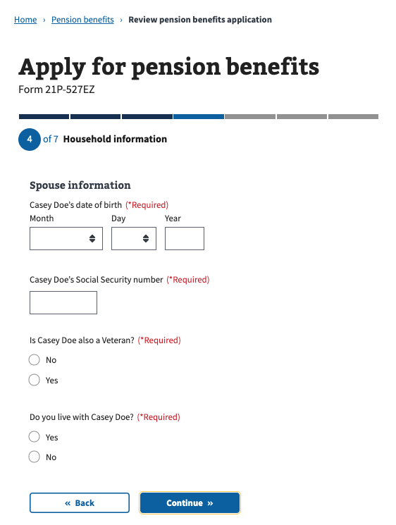

### Step 4: Household information / Current marriage, if they do not live with spouse

Next, if the veteran answered that they do not live with their current spouse, the next page will ask them what their spouse’s address is:

### Step 4: Household information / Current marriage, if they are separated

Next, if the veteran answered “separated” to their current marital stat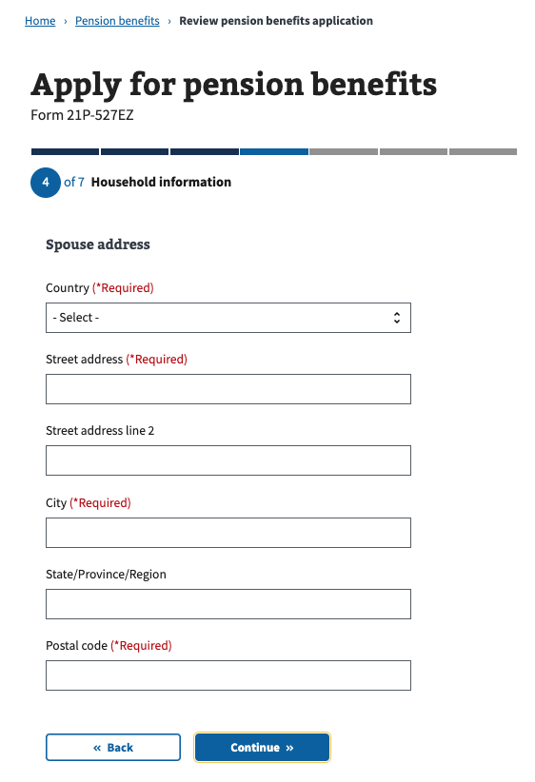us, in addition to their spouse’s address, they will also be asked if about a reason they are separated, and how much money they contribute each month to their spouse’s support:

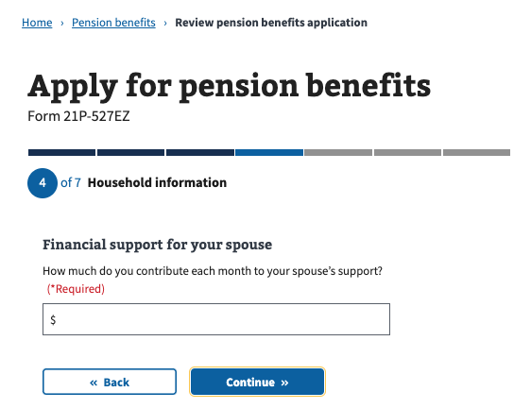

### Step 4: Household information / If married or separated

Next, if the veteran answered “married” or “separated”, they will be asked if their current spouse has been married before.

### Step 4: Household information / If married or separated / If current spouse has been married before

Next, if the veterans current spouse has been married before, they will be asked 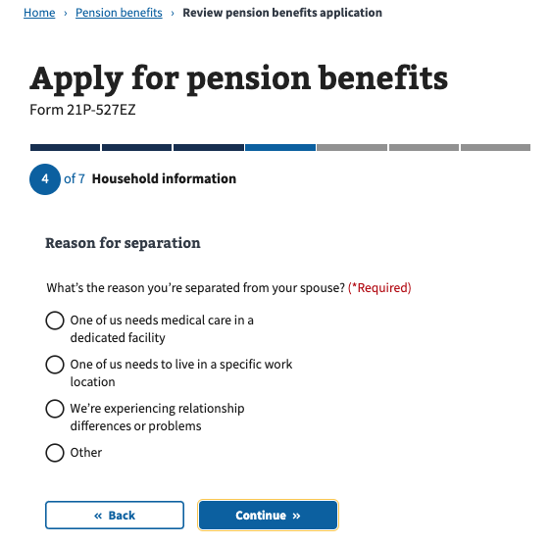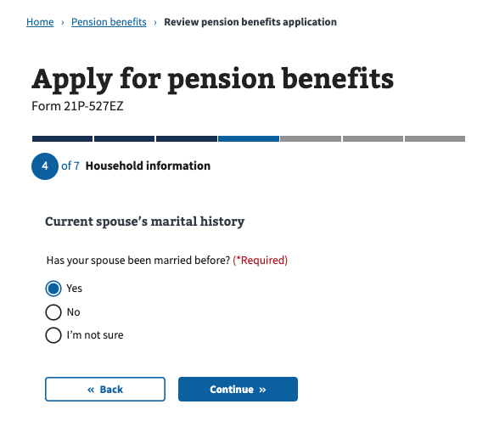about their spouse’s former marriage, including their spouse’s former spouse’s name, how their marriage ended, marriage start and end dates, places where marriage started and ended:

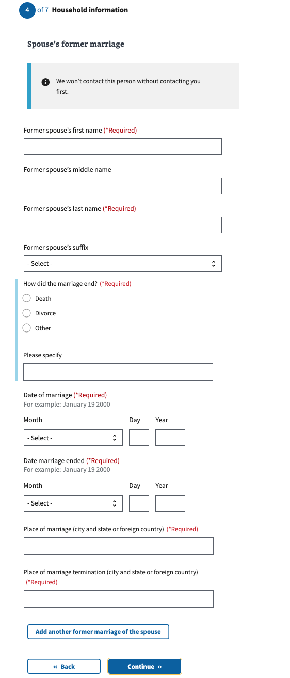

### Step 4: Household information / Dependent children

Next, the veteran will be asked if they have any dependent children.

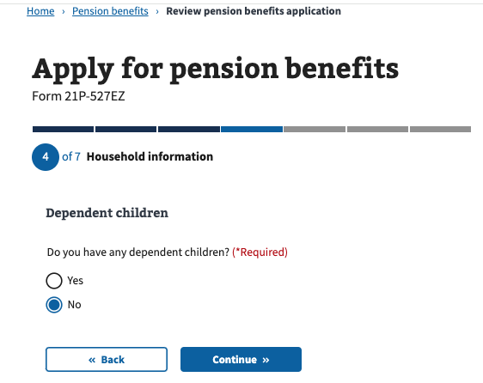

If they answer “yes”, they will be asked about their children’s name, and date of birth. They will also be asked about their place of birth, social security number, their relationship with them, if they are seriously disabled, if they are ins school (if they are under years old), and if they’ve ever been married (if so, if they are currently married):

If the veteran does not have dependent children, they will skip to the Financial information section.

### Step 5: Financial information / Income and assets

Next, the veteran will be asked if they and/or dependents have over $25,000 in assets.

If they answer “yes” they will see a warning that asks them to fill out form 21P-0969

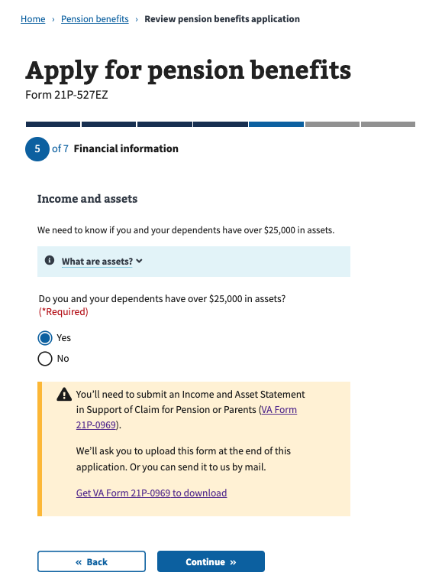

If they answer “no” they will be asked what their total value of their assets is:

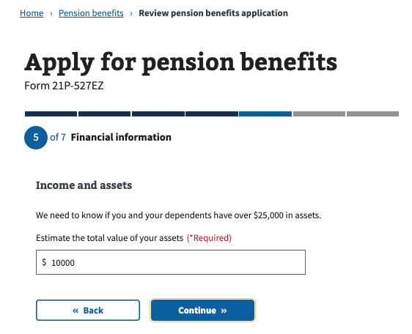

Next, the veteran will be asked if they and/or dependents have transferred any assets in the last 3 calendar days.

If they answer “yes” they will see a warning that asks them to fill out form 21P-0969

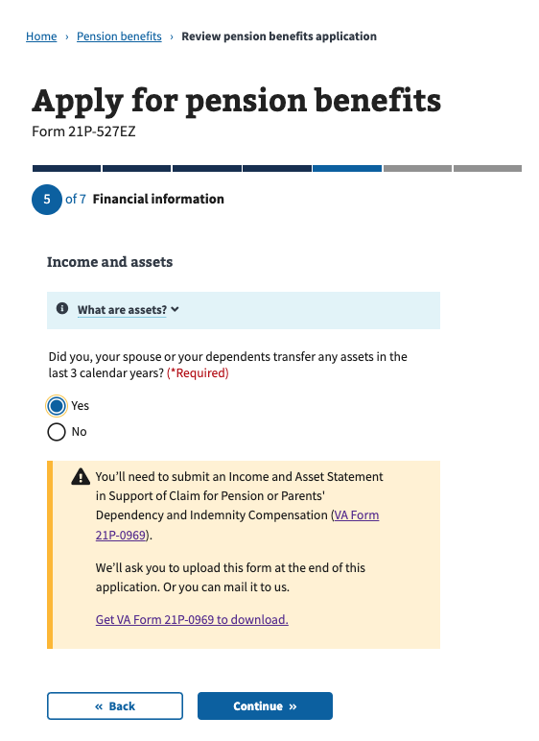

Next, the veteran will be asked if they and/or dependents own their home:

If they answer “no”, they will skip to the section that asks about Gross Monthly Income.

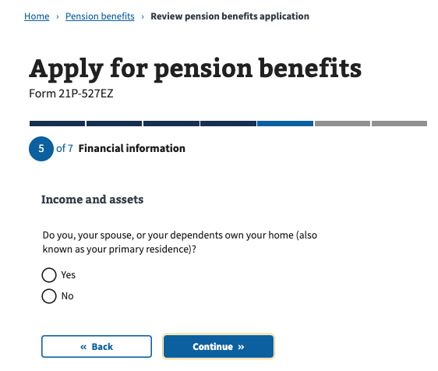

If they answer “yes” to owning their home, they will be asked if their home is located on a lot of land that’s more than 2 acres:

If they answer “no”, they will skip to the section that asks about Gross Monthly Income.

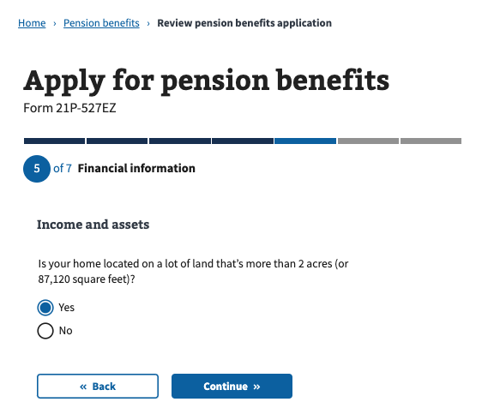

If they answer “yes” to owning their home, they will be asked that the value of their land that’s more than 2 acres is: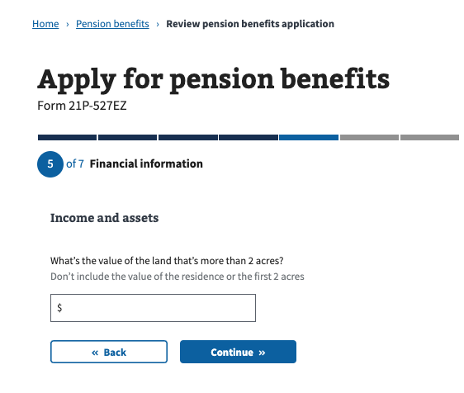

If they answer “yes” to owning a home located on more than 2 acres, they will be asked if their additional land is marketable: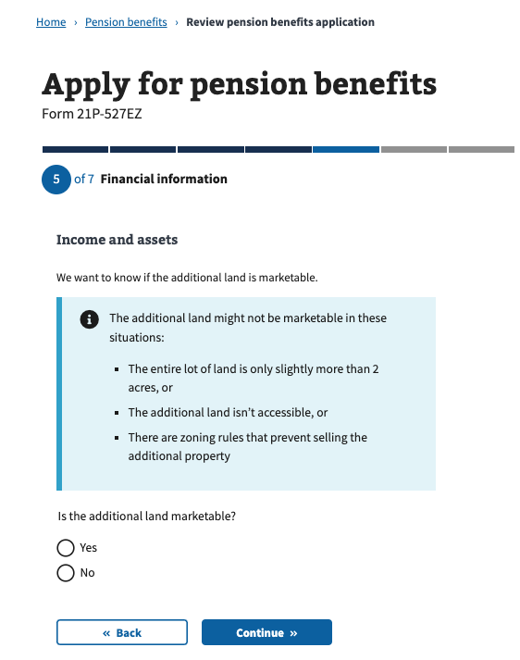

### Step 5: Financial information / Gross monthly income

Next, the veteran will be asked if they and/or dependents receive any income.

If they answer “no”, they will skip to the section that asks about Care Expenses.

If they answer “yes”, they will be asked to enter their type of income, who receives the income, who pays the income, and what the monthly amount is:

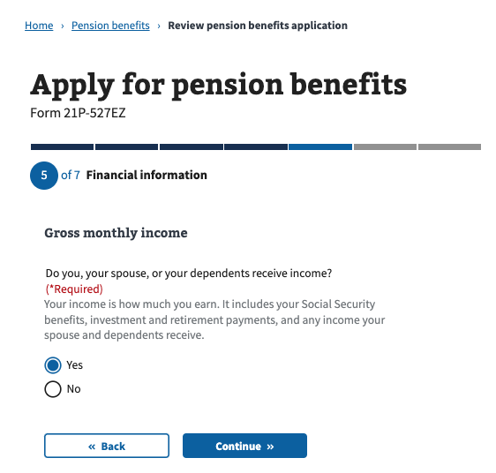

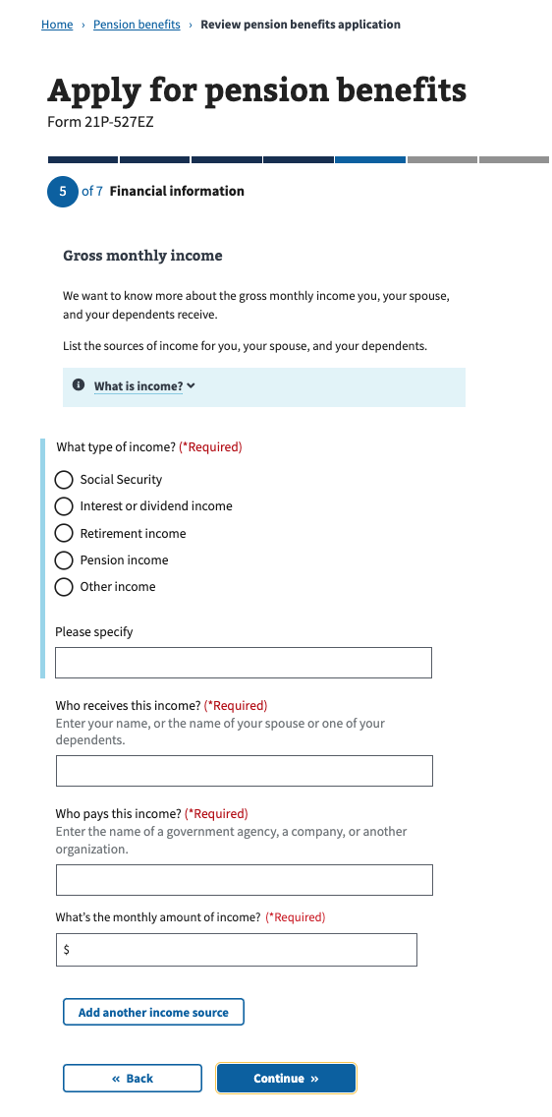

### Step 5: Financial information / Care expenses

Next, the veteran will be asked if they and/or dependents pay any recurring care expenses that are not reimbursed.

If they answer “no”, they will skip to the section that asks about Medical Expenses.

If they answer “yes”, they will be asked who receives the care, the name of the care provider, the type of care, what the rate per hour is, how many hours per week their care provider works, the start and end dates of the care, how often their payments are and how much is each payment:

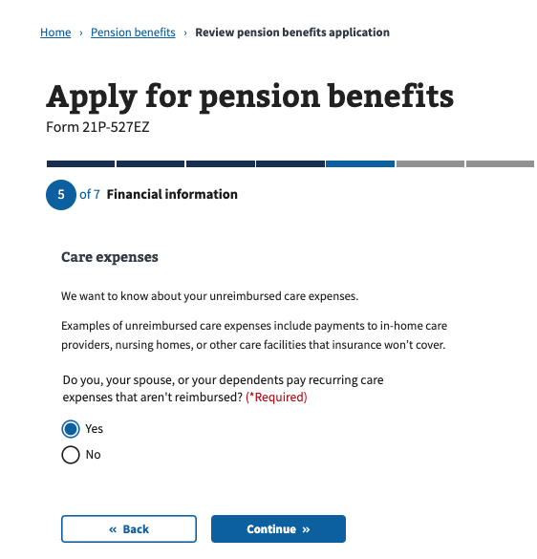

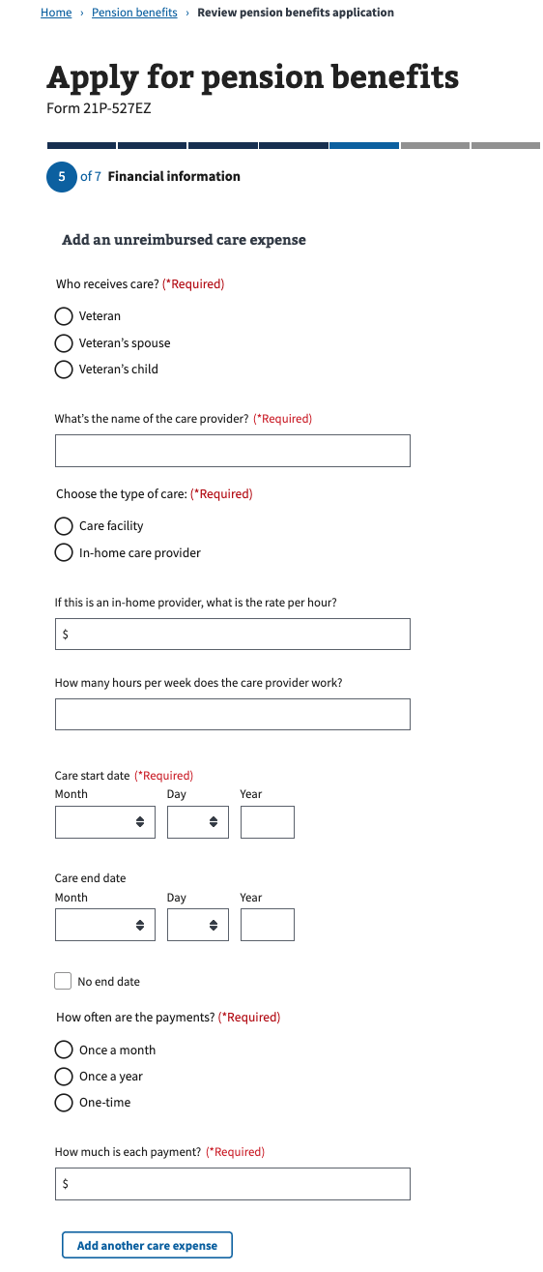

### Step 5: Financial information / Medical expenses

Next, the veteran will be asked if they and/or dependents pay any medical or other expenses that re not reimbursed.

If they answer “no”, they will skip to the section to enter their Direct Deposit information.

If they answer “yes”, they will be asked who receives the care, who receives the payment, what the payment is for, date of payment, how often the payments are and how much each payment is:

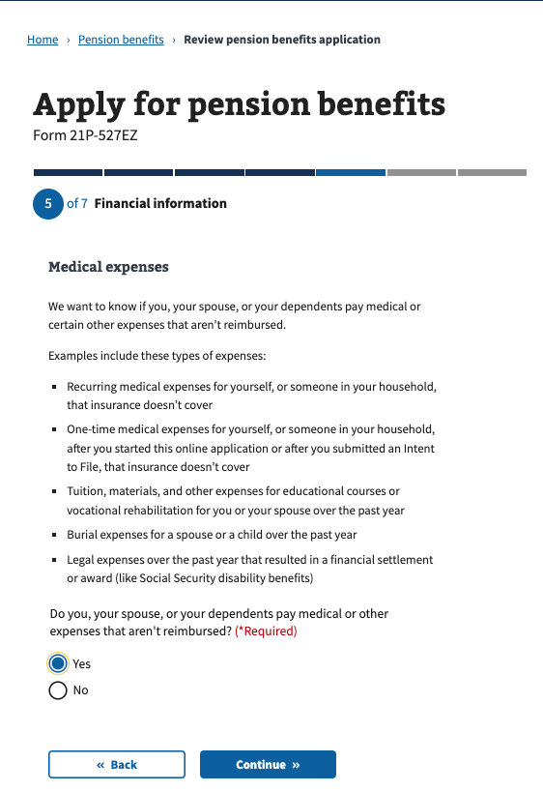

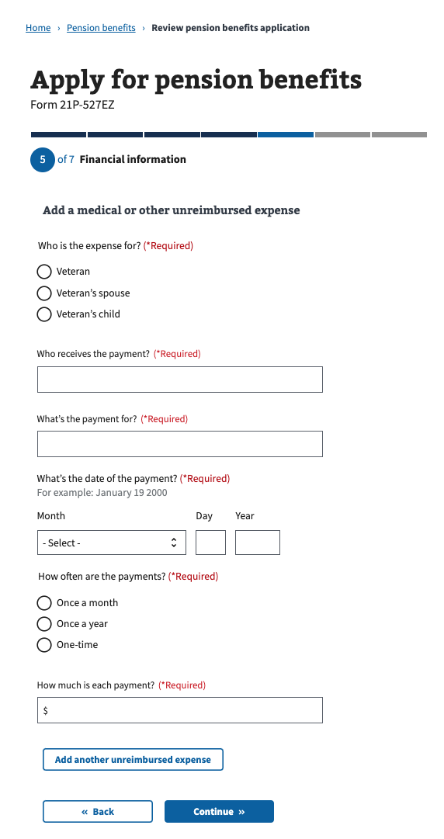

### Step 6: Additional information / Direct deposit

Next, the veteran will be asked if they want to add their bank account information for direct deposit if they choose to:

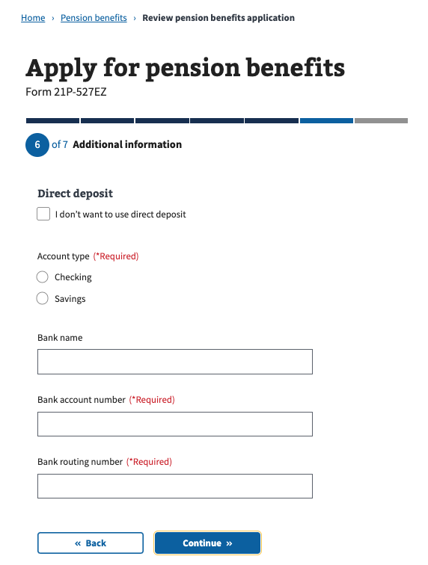

### Step 6: Additional information / Supporting documents

Next, the veteran will be shown more information about what other types of supporting documentation they will need to submit:

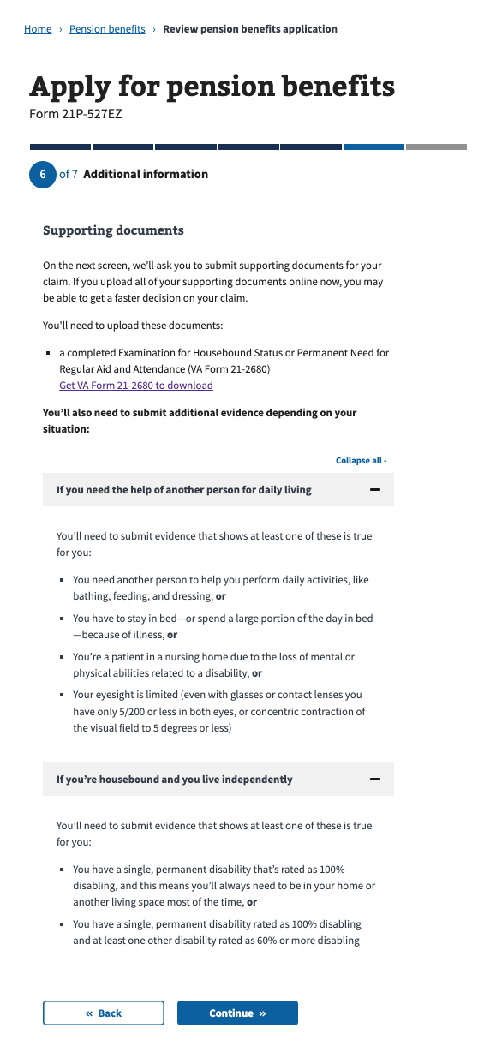

### Step 6: Additional information / Submit your supporting documents

Next, the veteran will have the ability to submit any supporting documentation at this time. They will also be shown more information about other options to submit, including using the AccessVA tool (QuickSubmit) or mailing their documents:

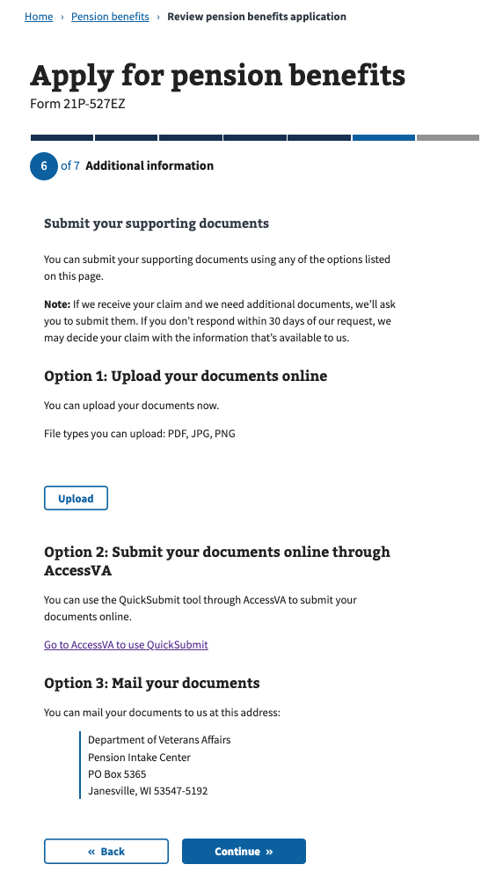

### Step 6: Additional information / Faster claim processing (optional)

Next, the veteran will be shown more information about whether they want to use the “Fully. Developed Claims” program. This is only for applicants who state they have uploaded all of their supporting documentation: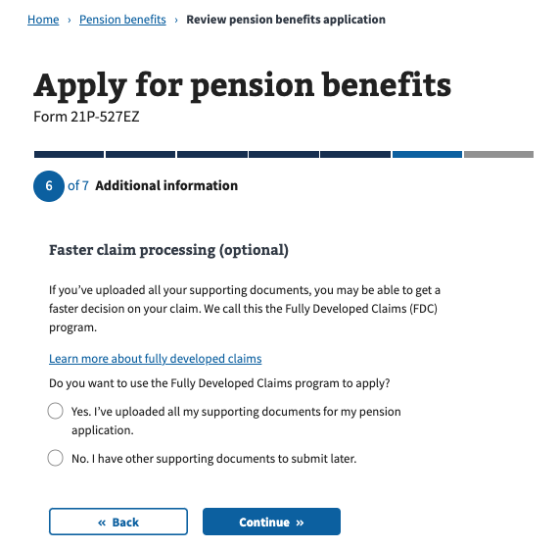

### Step 7: Review application

Next, the application will come to a Review section. This is the last step of the fo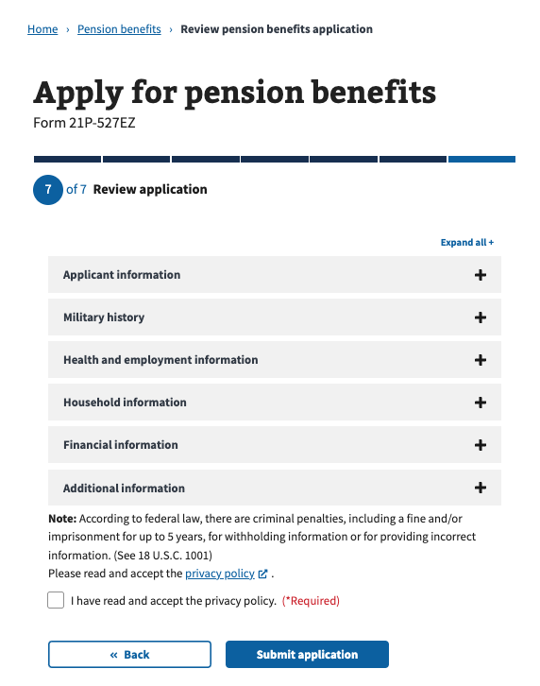rm before they submit, where they will see a summary of all the questions they were asked, as well as any information they entered: